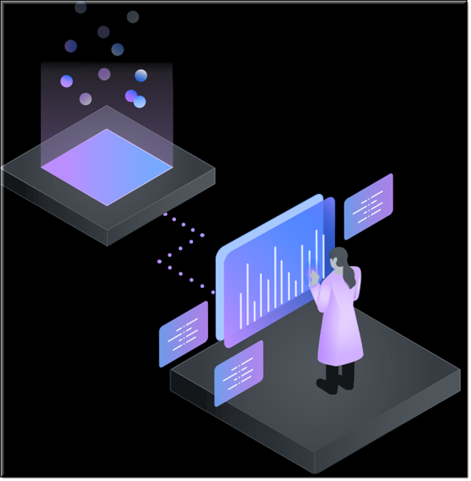

I B M C L O U D P AK F OR D A T A

JOURNEY TO CLOUD AND AI

ANALYTICS MODERNIZATION WORKSHOP

Day | Month Date, Year | Time

Address





CHANGING THE GAME: WINNING WITH AI
This workshop provides a hands-on walkthrough of the entire Cloud Pak for Data offering, the world’s premier “Analytics Modernization” platform. The workshop is supported by a presentation that helps attendees understand why Cloud Pak for Data is necessary in our modern analytics driven world. The labs show how your organization can receive tremendous time-to-value in its “journey to cloud and AI.”

ANALYTICS MODERNIZATION JOURNEY

Collect
-Connect to various source repositories, including Db2, MongoDB, and MySQL
-Virtualize data: leave the data where it is (anywhere) and leverage it efficiently for your analytic projects

Organize
-Explore, refine, profile and visualize data
-Explore, add, update business categories and terms, reference datasets, and more
-Govern data with masking, policies and rules, lineage and relationships visualization
-Search for data in an enterprise catalog
-Transform multiple data sources into one cleansed source to be used for further analysis

Analyze
-Use AutoAI to create the best possible machine learning model for your application - with no coding
-Create a machine learning model using a Jupyter notebook in Python
-Create analytics dashboards to better understand your business

Deploy
-Deploy the machine learning model and test it with APls or curl

Infuse
-Use Watson OpenScale to infuse your models into your apps, detecting and mitigating drift and bias
-Use Cognos Analytics to embed visualizations and reporting directly into your applications
This event is by invitation only and has limited seating.
It is targeted for Chief Data Officers, Data Scientists, Business Analysts, Data Engineers, Data Stewards, and anyone interested in improving their “time to value” by gaining insight from data and streamlining the process of automating machine learning model creation and deployment for AI infused applications.

